Strategies for Sustainability
Webinar 2 - Additional Resources
Thank you for joining us for Webinar 2: Business Sustainability Frameworks!
On this page you will find some additional resources which expand on the content we covered in Webinar 2. These additional resources are not required to be utilised but are recommended reading for your increased understanding of strategies for sustainability.

ESG Reporting Frameworks / Certifications:
A few of the major sustainability reporting frameworks are highlighted below with a link to a description of their reporting standards, recommendations, or guidance, and a link to any of the case studies we outlined for each in the webinar.
Table 1-1 Sustainability Reporting Frameworks
Framework / Certification | Link to guidance | Link to Action tools or Case Studies
United Nations Sustainable Development Goals (UNSDGs) | UN SDGs | SDG Action Ideas – What Can You Do  Impact Measurement – IRIS+  SDG Action Manager – B Corp
Global Reporting Initiative (GRI) | GRI Standards  GRI Agriculture Sector Standard | GRI among SMEs – Zamusi Projects
Certified B Corporation (B Corp)  B Impact Assessment (BIA) | B Corp  BIA | B Impact Assessment case studies
Task Force on Climate-Related Financial Disclosures (TCFD) | TCFD Recommendations
Carbon Disclosure Project (CDP) | CDP

Glossary for Common Sustainability Terminology:
https://www.mckinsey.com/business-functions/sustainability/our-insights/more-than-values-the-value-based-sustainability-reporting-that-investors-want

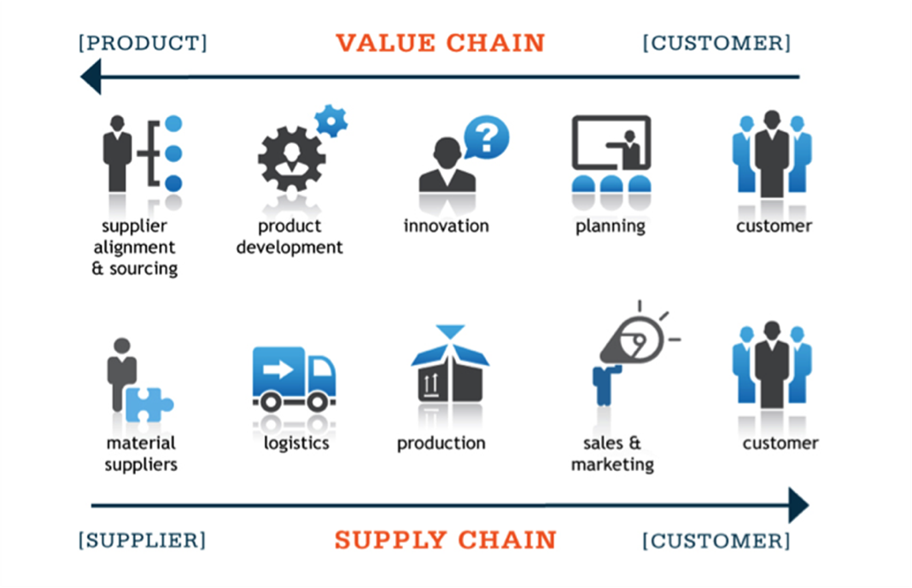
Homework: What is your supply and value chain?
Objectives:
- Understand your value chain/supply chain and where your business
has a positive or negative impact
- Understand your markets and consumers
- Understand the priorities of the governments your business operates under

Have a go at filling out the below table for your business:
 | - From your business strategy | - Based on your answers in Column A, conduct a review of peers and markets
What is your end market?  (List product and services by Country/Area) |  | What standards are commonly used for your product or service in that market?
Who are your consumers / customers? (List consumer demographic eg premium affluent market, local market) |  | Are your customers willing to pay a premium for a certified product?
What companies do you supply products or services to? |  | Do the companies you supply to report on sustainability? If so what standard do they use?
Who are your suppliers?  (Where do you get your raw products from?) |  | Do the suppliers report on their sustainability?
Business Setting
What government do you operate under? |  | Do they have any priorities or regulations you need to consider in your activities?
What are the common Environmental issues for your sector?
What are the common Social and Governance issues for your sector?

